Ashley Mellon
Dr. Gardner/ Dr. Dufresne
ARTS 482 ART OF THE BOOK
1 May 2011
Merging the Past and Present: The Altered Collage Book as Homage to Winthrop’s Prominent Women
In honor in Winthrop’s 125th Anniversary, I was interested in finding a way to actually connect the past to the present. My interest in feminist studies led me to the realization that there are three major buildings, McBryde Hall, Margaret Nance Dormitory originally called North Dormitory, and the Lois Rhame West Health Physical Education and Wellness Center, named after three distinguished women in the Winthrop community. Through collage, I created an altered book to conceptually commemorate and demonstrate the lasting legacy these women, Sarah Crosby Chappell McBryde, Margaret White Johnson Nance, and Lois West, have left. These women have helped contribute to the places current and future students of Winthrop continue to enjoy and will later reflect on as a collective part of the Winthrop experience.
I was essentially drawn to the “altered book form” because of how fascinating it is to recycle and reuse materials and make them into a creation completely different than the original. I approached my piece as a sculptural piece by sanding down the pages and sawing them into different shapes so that the form of the book was not square. Linda Kopp examines in 500 Handmade Books: Inspiring Interpretations of a Timeless Form that, “the book is a perfect union of form and function, and as such has proven to be endlessly adaptable to aesthetic and technological innovation. But now this companionable design marvel—this vessel for literature, entertainment, information, transformation, and transcendence—is facing an uncertain future as texts are digitized and the quest for affordable, reader-friendly e-book devices intensifies. So what better time to take a step back and ponder the thingness of books? Books as objects; books as sculptures” (23). After originally created the altered book project in class, I was amazed at how fascinated I was with the process and how much one can change the composition and meaning of the book by altering it.
To alter my book, I collaged parts of it to show the merging of the past and present. Influential Visual Art Critic, Clement Greenberg states in Art and Culture that “the term collage derives from the French word “colle” meaning glue. This term was coined by both Georges Braque and Pablo Picasso in the beginning of the 20th century when collage became a distinctive part of modern art” (122) The use of collage worked well with the concept of my project because I wanted to demonstrate the merging of the past and present in a vintage way. Through collage, I was able to convey deeper ideas through a mirage of images. Artists Nita Leland and Virginia Lee state in Creative Collage Techniques that, “Collage has a long and distinguished history. The story begins with the invention of paper in China around 200 B.C., but the earliest examples of paper collage are the work of twelfth-century Japanese calligraphers, who prepared surfaces for their poems by gluing bits of paper and fabric to create a background for brushstrokes” (111). Today’s collage artists invent exciting variations of these ancient collage techniques. Artists in medieval times, beginning in the thirteenth century, often enhanced religious images with gemstones, elegant fibers, relics and precious metals. Leland and Lee go on to state that later, “in the seventeenth and eighteenth centuries, nuns made bookmarks trimmed with cut and colored papers, which they carried in their prayer books” (134). Frequently, the materials used were selected for their symbolism, a practice that continues in contemporary collage.
One of the particular elements of collage that I liked best when creating my final project is how easy it is to manipulate and alter the surface of collage even in book format. I played with variations of textures to create a variety and to avoid monotony of simply “pasting images”. Through doing this and also painting over the surfaces to create a different variation, I was able to show the contrast of past images and the present. Leland and Lee state, “Collage may be seen as a quintessential twentieth-century art form with multiple layers and signposts pointing to the possibility or suggestion of countless new realities” (34). College allows the viewer to add and create meaning to the piece.
Art historians generally attribute the first use of collage in fine art to Pablo Picasso in 1912, when he glued a piece of patterned oilcloth to a cubist still life. George F. Brommer examines in Collage Techniques: A Guide for Artists and Illustrators that, “Collage as a fine art medium, however, emerged with the cubist pasting and gluing experiments of Georges Braque and Pablo Picasso in France in 1912” (13). As seen in figure 1, in comparison to Figures 2 and 3, Picasso merged elements in a new way, but with fine art principles. Over time, Hannah Hoch revolutionized collage with her radical photomontaging.

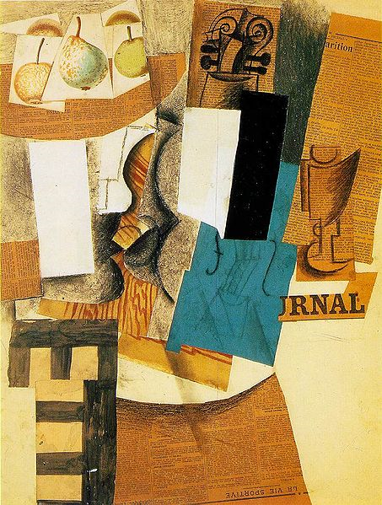
Figure 1: Compotier avec fruits, violon et verre. Pablo Picasso (1912)
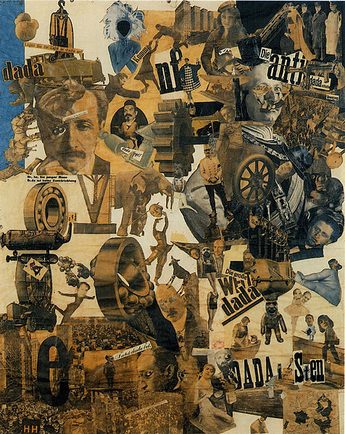
Figure 2: Hannah Hoch, Cut with the Dada Kitchen Knife through the Last Weimar Beer-Belly

The use of foreign materials in paintings angered critics, adding more fuel to the creative fires of experimental artists. The avant-garde adopted this outlook; cubists used mostly paper and paint, sometimes in a patchwork quilt fashion, with the occasional realistic object added to support a pictorial concept or philosophical viewpoint. As stated by Steve Edwards in Art of the Avant-Gardes , “Futurists incorporated typography for political commentary and added found objects to connect art with the real world. Dadaists found collage an ideal means of expressing anti-art nonsense, bringing together outrageous combination of materials for shock value” (55). Psychology led surrealists to see collage as a revelation of unconscious thoughts brought to the surface through the placement and selection of materials.

As stated in Peter Boswell, Maria Makela, and Carolyn Lanchner’s The Photomontages of Hannah Hoch, “ Hannah Hoch was mostly known as the sole female member of the Berlin DADA movement and was a pioneer of photomontage. The intricate imagery of her montage work explores her fragmented life as a woman within a male dominated art movement. I found Hannah Hoch’s work inspirational for this specific assignment because she is heavily influenced by gender bias and limitations. This relates to Winthrop’s 125 Anniversary because Winthrop was originally a women’s college and over time evolved to be co-ed. The gender role of the women was originally much more stereotypically oppress, but artists like Hoch fought for equality. I was able to obtain photographs of Sarah Crosby Chappell McBryde, Margaret White Johnson Nance, and Lois West from Winthrop’s Archives and I was able to use their actual pictures.
While it can be used alone, collage is also often combined with other media (painting, drawing, and printmaking) in various forms of individual communication. Collage is used to explore ideas, advocate concepts, and develop possible directions in which to work; but just as often it is a skilled and practiced means of personal visual expression.

Works Cited
Brommer, Gerald F. Collage Techniques a Guide for Artists and Illustrators. New York, NY: Watson-Guptill, 2007. Print.
Edwards, Steve. Art of the Avant-Gardes. London: Yale UP in Association with the Open University, 2004. Print.
Höch, Hannah, Peter W. Boswell, Maria Martha. Makela, Carolyn Lanchner, and Kristin Makholm. The Photomontages of Hannah Höch. Minneapolis: Walker Art Center, 1996. Print.
Kobb, Linda. 500 Handmade Books: Inspiring Interpretations of a Timeless Form. New York: Lark, 2008. Print.
Leland, Nita, and Virginia Lee Williams. Creative Collage Techniques. Cincinnati, OH: North Light, 1994. Print.

